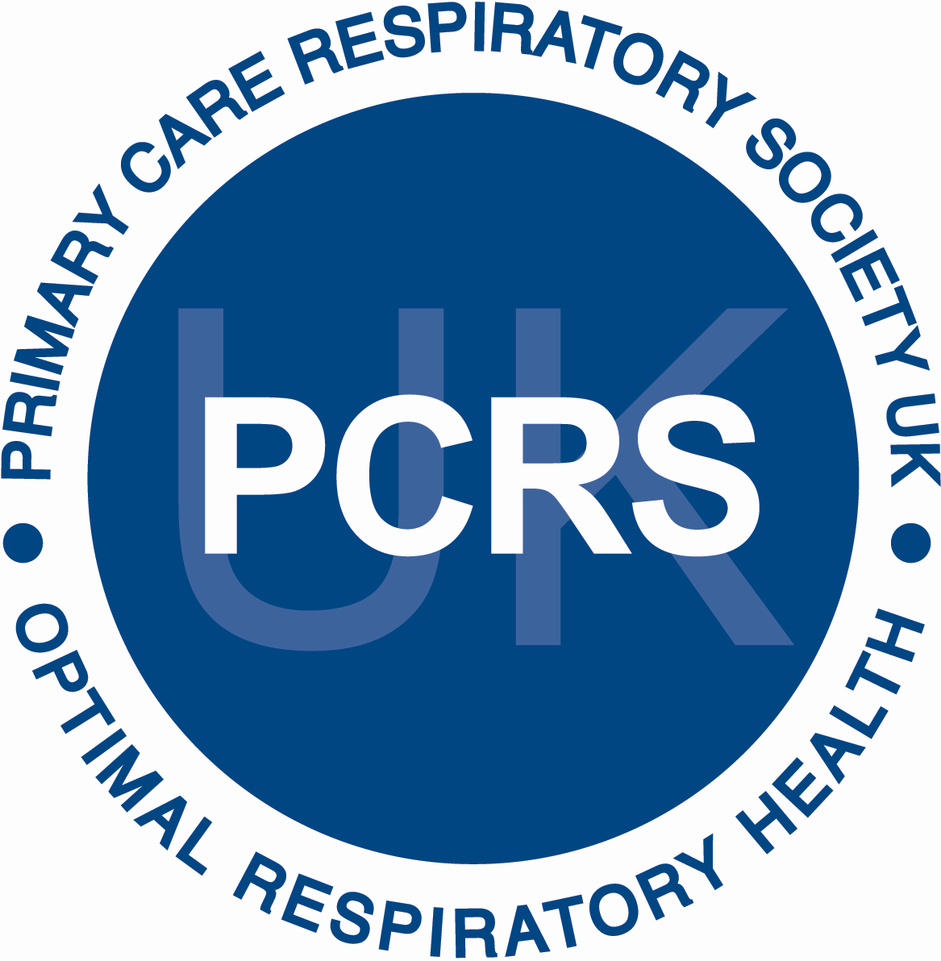
Summary of recommendation
Skill Levels for Delivering High Quality Respiratory Care by Nurses in Primary Care

September 2007
Revised December 2009, 2014, 2015

Original Author: Ruth McArthur
Edited by Sally Harris
Contributions:
Debbie Roots, Carol Stonham, Steph Wolfe

©PCRS-UK . All rights reserved. No part of this publication may be reproduced, stored in a retrieval system or transmitted,
in any form or by any means, without the prior permission of the PCRS-UK.

The Primary Care Respiratory Society, is a registered charity
(Charity No: 1098117) and a company limited by guarantee registered in England (Company No: 4298947)
VAT Registration Number: 866 1543 09
Address: PCRS-UK, Unit 2 Warwick House, Kingsbury Road, Curdworth, Warwicks, B76 9EE
Telephone: +44 (0)1675 477600 Facsimile: +44 (0) 121 336 1914 Email: info@pcrs-uk.org Website: http://www.pcrs-uk.org

There are some core skills that are integral to respiratory nursing. The skills guide includes essential elements that should be included in procedures/policies and assessments. Nurses should comply with local procedures/policies at all times. This document can be used to demonstrate safe practice in line with NMC Code of Conduct and additional as part of the Revalidation Process'

Skill levels for delivering high quality respiratory care by nurses in primary care, as recommended by the PCRS-UK.

Minimal Involvement in Respiratory Care

- Respiratory patients seen by this nurse or allied health professional already have a diagnosis made
- Routine review may be undertaken where inhaler technique and peak flow (asthma) are checked
- A basic understanding of the disease processes is required
- Basic history taking as per a recognised respiratory template, asking the 3 RCP questions with symptom scoring or use of the ACT questionnaire for asthma or COPD Assessment Test (CAT) for COPD patients
- Checking concordance with regularly prescribed (respiratory) medication
- Ascertaining smoking status and giving cessation advice where appropriate – referring to specialist smoking cessation services as required
- Offering influenza and pneumococcal vaccination to respiratory patients
- Problem identification and appropriate referral, working collaboratively across the multi-disciplinary team

Medium Involvement in Respiratory Care

- All of the minimum requirements and skills plus
- Ongoing experience in dealing with respiratory patients
- Patients seen by a nurse at this level could require a diagnosis to be made by them differentiating between common respiratory conditions such as asthma and COPD
- Use of protocols to guide diagnostic and therapeutic options
- Perform more detailed diagnostic testing e.g. reversibility testing, and monitoring e.g. pulse oximetry
- Initiate(if an independent prescriber) otherwise discuss treatment options and assess trials of different treatments
- Referral of patients when necessary e.g. to pulmonary rehabilitation
- Discussion and development of self-management education and the use of self-management plans
- Supporting peers and colleagues in the dissemination of respiratory guidance and information

Maximum involvement in respiratory care

- Nurses with all of the minimum and medium skills plus
- Seeing patients without a confirmed diagnosis
Skills required include -
- History taking, examination skills + or – auscultation skills, knowledge and interpretation of investigations such as spirometry, pulse oximetry etc.
- Would usually follow diagnostic pathways and recognised guidelines with expertise to recognise areas of uncertainty
- In depth knowledge of drug treatments and therapeutic options
- Knowledge of appropriate onward referral at a specialised level
- Acting as a mentor and advisor to healthcare professional colleagues and promoting high standards of respiratory care

Introduction

The PCRS-UK Nurse Committee recognised that there is a need for standardisation of respiratory care and a definite need to provide some form of standardised education and support for nurses who regularly care for and make decisions with people with respiratory disease in primary care.

Whilst there are a group of nurses in primary care who have taken a clear lead in learning more about respiratory care, there is a wider community of nurses who work as generalists but are involved in the management of respiratory diseases on a day-to-day basis. This document, written by Ruth McArthur with original input from the PCRS-UK Nurse Committee, the Respiratory Nurse Alliance, and the Scottish Respiratory Nurse Forum (SRNF) outlines the standards and skills required from the individual primary care nurse at three clear levels: minimal, medium and maximum which have been adapted from the National Respiratory Training Centre (now Education for Health) original skills level set for asthma. The document has been last updated and edited by PCRS-UK in 2015.

Skill levels for delivering high quality respiratory care by nurses in primary care

There are several levels of expertise, training, tasks, and responsibilities necessary to deliver respiratory care within a primary care setting and all nurses work under their own professional code of conduct as accountable autonomous practitioners.

It should be noted that nurses in primary care will not be the only group of healthcare professionals providing respiratory care for those living with a long-term condition such as asthma or COPD.

Currently, registered practitioners such as emergency care practitioners (ECPs), public health nurses, treatment room nurses, pharmacists, school nurses, community nurses, community matrons and nurse practitioners are also involved in delivering care within a primary care/community setting. However at present, as the PCRS-UK current nurse membership is mainly comprised of nurses in primary care, this document is directed at providing advice and support towards them in particular.

What is the role of PCRS-UK?

The Primary Care Respiratory Society (PCRS-UK) is an independent charity representing primary care health professionals interested in delivering the best standards of respiratory care. It is dedicated to achieving optimal respiratory care for all, through:
- Representing primary care respiratory health needs at policy level
- Promoting best practice in primary care respiratory health through education, training and other services
- Supporting the development of primary care health professionals in respiratory medicine
- Facilitating and leading primary care respiratory research

The PCRS-UK, has developed recommendations on the levels of involvement and the skill levels necessary to deliver safe, high quality care to patients with respiratory disease. The PCRS-UK is not a training provider itself but can sign-post interested individuals to recognised accredited training providers such as the Association for Respiratory Technology and Physiology, Education for Health, Respiratory Education UK and other accredited regional providers, etc. The PCRS-UK is not involved with assessing skill levels or competencies.

Who will this be document be useful for:

For nurses and service managers: to guide personal development planning by highlighting the support and development needed to promote effective working, and career progression, which maps with the NHS Knowledge and Skills Framework. The document can also be used to support training requirements and reflection to support NMC Revalidation (www.nmc.org.uk)

For service users and their families/carers: to explain the key skills, knowledge and attitudes that they should expect from nurses practicing Respiratory care.

For education and training organisations: to guide the development of training and educational activities and programmes specific to Respiratory care.

NHS Knowledge and Skills Framework (KSF) in relation to skill levels

The purpose of The NHS Knowledge and Skills Framework (KSF) is to enable nurses to identify their competence development as they progress through the career levels, linking it to the specialist area of practice in which they work.

The KSF was published by the DOH in October 2004 and has been used to ensure that nurses are meeting the expected levels for career progression within the remit of Agenda for Change, as well as identifying the knowledge and skills that needs to be applied to practice areas.

PCRS-UK recognise the value of this document and is suggesting that those nurses who wish to progress in their specialist skills of providing care for respiratory patients should have a framework on which to base their level of involvement.

Using the Royal College of Nursing framework, nurses will be able to achieve multiple agendas within one portfolio to demonstrate:

- Skills at different levels in general and specialist areas of nursing
- Readiness to progress to the next career level using the tools that can help nurses
become professionally accredited
- Achievement of the KSF in relation to one’s own job profile/post outline pay band

Key Knowledge Skills and Behaviours

- A broad knowledge and understanding of Respiratory Disorders underpinned by theoretical knowledge and relevant clinical experience, skills and competence.
- Knowledge and understanding of clinical governance framework within own organisation, legislation, policies, procedures, protocols, professional regulation and codes of practice. Works with patient group directions and/or standing orders

Practitioner Level 5: Registered practitioners consolidating pre-registration experience and getting ready for a higher level of functioning –Practice Nurses who are involved with patients who have Asthma/COPD post diagnosis in primary care.

Essential:
Local NHS approved training/in house training/ or mentorship from more senior colleagues with respiratory experience

Desirable: working towards:
Respiratory Assessment e.g. diploma modules such as
- Asthma graduate diploma module
- COPD graduate diploma module

Respiratory reviews of patients with stable respiratory disorders in the community | Community Nurse Essential:  Local NHS approved training  Desirable:  Respiratory Assessment diploma module e.g. Asthma and COPD graduate diploma modules  Respiratory failure graduate diploma module

Senior Practitioners Level 6: A higher degree of autonomy and responsibility than level 5 in the clinical environment. Nurses who are making Asthma/COPD diagnosis & managing these conditions in primary care or the community.
Demonstrates specialist knowledge, competence and clinical skills in respiratory care and management appropriate to the patients needs. | - Practitioner must work as part of a team, using specialist knowledge and skills to provide and enhance clinical care.  - Work within a clinical governance framework providing appropriate clinical supervision.  - Assume accountability and responsibility for delivery of whole episodes of care including:  - assessment and diagnosis intervention and referral  - Ensure delivery of safe and effective care using evidence informed practice.  - Work independently by virtue of specialist knowledge and skills e.g. provision of nurse-led clinics | - Detailed specialist knowledge of respiratory disorders underpinned by theoretical work and relevant clinical experience, competence and skills  - Knowledge and understanding of clinical governance framework within own organisation  - Work with patient group directions or Standing Orders Additional specific clinical competencies as required e.g. spirometry  - Knowledge of range and needs of vulnerable and hard to reach groups

Essential:
Respiratory Assessment graduate diploma module
Asthma graduate diploma module
COPD graduate diploma module

Desirable:
Graduate certificate or degree in respiratory disorders

Advanced Practitioner Level 7: Experienced clinical practitioners with high level of skill and theoretical knowledge. Will make high level clinical decisions and manage own workload.

Four central themes underpin each level.
- Leadership
- Research and Development
- Facilitation of Learning
- Clinical Practice (including skills)

- Nurses should participate in life-long learning by accessing and utilising learning materials from a wide variety of sources to inform professional practice
- Provide written and verbal feedback on learning from study days/courses to other members of the team
- Use a range of teaching methods to enable patient learning
- Guide and direct patients and carers to services such as voluntary organisations
- Identify the needs of the local population with regard to health & well being
- Be accountable and responsible for own actions in assessment and care planning ensuring continuity of care
- Undertake specialist interventions, treatments, therapies for the patient group in partnership
- Demonstrate working knowledge of the key specialist interventions, treatments etc. appropriate to the patient group being cared for

Skill levels for delivering high quality respiratory care by nurses in primary care, as recommended by the PCRS-UK

Minimal Involvement in Respiratory Care

- Respiratory patients seen by this nurse or allied health professional already have a diagnosis made
- Routine review may be undertaken where inhaler technique and peak flow (asthma) are checked
A basic understanding of the disease processes is required
- Basic history taking as per a recognised respiratory template, asking the 3 RCP questions with symptom scoring or use of the ACT questionnaire /or CAT for COPD patients
- Checking concordance with regularly prescribed (respiratory) medication
- Ascertaining smoking status and giving cessation advice where appropriate – referring to specialist smoking cessation services as required
- Problem identification and referral

A nurse working at this level in delivering respiratory care should have in-house training and support and at the very least be able to access an essential skills/short course (respiratory) which will equip them with the necessary skill levels to deliver care at this level.

Recommended training organisations and training opportunities can be found on the
PCRS-UK website. Nurses working at this level will need to keep their skills /knowledge updated and would benefit from joining a local respiratory primary care nurse group and/or the PCRS-UK (http://www.pcrs-uk/org).

Medium Involvement in Respiratory Care

- All of the minimum requirements and skills plus
- Ongoing experience in dealing with respiratory patients
- Patients seen by a nurse at this level could require a diagnosis to be made by them differentiating between common respiratory conditions such as asthma and COPD
- Use of protocols to guide diagnostic and therapeutic options
- Initiate(if an independent prescriber) otherwise discuss treatment options and assess trials of different treatments
- Referral of patients when necessary e.g. to pulmonary rehabilitation
- Discussion and development of self-management education and the use of self-management plans for patients with asthma/COPD
- Referral of patients when necessary
- Supporting peers and colleagues in the dissemination of respiratory guidance and information

A nurse working at this level should be enrolled on a respiratory diploma level module or, if already in possession of a respiratory diploma, be able to access regular updates from a credible source.

Updating of knowledge and skills could be linked to ongoing professional development and appraisal, which links and describes this process.

This could be available from academic training organisations (for more formal updating) and from local professionals who can provide support in the clinical setting. Protocols and PGDs are available to members of the PCRS-UK at http://www.pcrs-uk/org.

Nurses need to be able to demonstrate continuous professional development and indicate in their annual appraisal where gaps in their knowledge lie and what steps require to be undertaken to update or maintain existing knowledge and skills.

Working at this level the nurse should expect to be able to support peers and colleagues and act as a resource for high standards of respiratory care within the practice providing training and ensuring national/local guidance is disseminated and complied with.

Maximum involvement in respiratory care

- Nurses with all of the minimum and medium skills plus
- Seeing patients without a confirmed diagnosis
Skills required include -
- History taking, examination skills + or – auscultation skills, knowledge and interpretation of investigations such as spirometry, pulse oximetry etc.
- Would usually follow diagnostic pathways and recognised guidelines with expertise to recognise areas of uncertainty
- In depth knowledge of drug treatments and therapeutic options
- Knowledge of appropriate onward referral at a specialised level
- Acting as a mentor and advisor to healthcare professional colleagues and promoting high standards of respiratory care

Nurses working at this advanced level will require to have experience in dealing with respiratory patients and to have accredited training - Minimum diploma(s), e.g. Asthma and COPD. It is also advantageous for nurses at this level to have studied respiratory modules at degree level.

The practitioner working at this level should also be encouraged to be a member of a respiratory interest group and attend regular updates/conferences ensuring his/her knowledge base remains current and evidence based. A nurse working at this level should also demonstrate continuous development in his/her role as reflected in his/her Professional Development Plan (PDP).

The practitioner working at this level should be promoting high standards of respiratory care and acting as mentor and support to other healthcare professionals within and outwith the practice.

