

# Respiratory Service Framework – Network Diagnostics Service Specification

**CONFIDENTIAL WORKING DRAFT – 6/9/19**

## The Respiratory Diagnostic Service Framework

Patients with respiratory disease deserve a correct diagnosis and correct guideline driven care that is standardized, patient focused, delivered by a Health Care Professional (HCP) with suitable training and experience, at a site and within an appropriate timeframe to meet their needs. Sadly, patient groups such as the British Lung Foundation (BLF) and Asthma UK have recognised that too often this is not the case. The Respiratory Diagnostic Service Framework (RSF) developed by the Primary Care Respiratory Society (PCRS) in conjunction with Cogora attempts to demonstrate what excellence is in terms of an RSF and how it may be delivered at a population level.

The RSF, developed by the PCRS Service Development Committee, has been designed specifically to assist those looking to establish a patient-focused diagnostic and respiratory diagnostic service. The diagnostic framework has been designed to encourage and support the development of diagnostic hubs or frameworks at a Primary Care Network (PCN) or Integrated Care System (ICS) level. It builds on the work previously undertaken by PCRS to develop a series of care standards for GP practices as part of its Quality Award programme. With the rise of integrated care systems and general practice at scale, commissioners and service development managers tell us they are keen to improve care and reduce variability but needed a starting point. The benefits of diagnostic services have been recognised by Commissioners and indeed many areas have already started to plan their development and this framework provides a template to aid that process, ensure standardisation and encourage high standards from a framework and workforce point of view. The RSF provides that starting point by describing the scope of best respiratory care and the services required.

## 2.0 The Network Respiratory Diagnostics Service Specification

This is a detailed, cost and resource modelled service specification for the diagnosis of chronic respiratory symptoms in adults aged 18 and over for a PCN sized population of 50,000 individuals. The common long-term conditions of asthma and chronic obstructive pulmonary disease (COPD) are the principle focus for the design of this specification. However, the service will also support better diagnosis of uncommon respiratory disease and other non-respiratory conditions where patients present with symptoms that may be considered to be respiratory-related. The PCN is a population described within current NHS England (NHSE) structures, but the specification could be equally applied to populations in the other three countries of the UK. This service specification is written to allow an extrapolation to smaller or greater population sizes.

### 2.1 Why has this specification been written?

We have a legacy of poor-quality diagnosis in both common and rare respiratory diseases. National audits and research using big data from general practice disease registers has shown for example that confidence in the diagnosis of COPD based on one key criteria – spirometry, is at worst 10% and at best 50%. (**Reference to NACAP 2017 report**; note this may be updated later this year). A retrospective review of the General Practice Research Database and Optimum Patient Care Research Database between 1990 and 2009 found that opportunities for diagnosis were missed in 85% of patients in the 5 years prior to a diagnosis of COPD (Jones et al 2014). People with interstitial lung disease are usually diagnosed x years after they first present with symptoms. This represents an unacceptable situation that is inequitable to the resource and efforts that are apportioned for earlier diagnosis of cancer yet the prognosis is often worse. Misdiagnosis exposes people to harmful pharmacotherapy that provides no benefit.

Breathlessness is a common and debilitating symptom and often regarded as self-inflicted (smoking) or age-associated by individuals who fail to seek medical help (Hopkinson and Baxter 2017). Breathlessness, particularly worsening breathlessness, is a strong prognostic indicator for hospitalisation and death (Figarska et al 2012). The drivers of chronic breathlessness are broad and often individuals will have multiple causation : tobacco, drug, alcohol dependence, obesity, deconditioning, respiratory disease (asthma, COPD, infection, bronchiectasis, Interstitial Lung Disease (ILD), lung cancer, TB, pulmonary embolism, asbestos lung disease, chest wall and diaphragm disease), non-respiratory disease (anaemia, liver disease, cardiac disease, thyroid disease, anxiety). Comprehensive and systematic assessment and diagnosis are critical steps to ensuring patients receive early and appropriate intervention and support whether they have one or multiple causes.

The purpose of a Respiratory Service Framework is to:

* Improve diagnosis of adults presenting in primary care with respiratory symptoms
* Increase the accurate and early diagnosis of adult asthma and COPD
* Improve the diagnosis of adults presenting in primary care with uncommon respiratory disease
* Enable identification (and appropriate referral) of patients with non-respiratory conditions who present in primary care with respiratory symptoms
* Ensure that patients are treated/referred to the appropriate care setting and in line with local guidance (including cough and breathlessness algorithms)
* Support the development and implementation of integrated diagnostic pathways for adults presenting with respiratory symptoms in primary care
* Ensure that users of the service have a coordinated and positive experience of care and that the service involves users in its development and responds to patient’s views as part of regular review.

### 2.2 Closing the Observed/expected prevalence gap for COPD and asthma

[**Input to be sought from Public Health colleagues and NHSE RightCare; metrics to be updated using Respiratory Atlas of Variation once published**]

* Respiratory symptoms
  + Breathlessness is thought to affect up to 10% of the adult population in the UK, increasing to 30% of older adults (Baxter 2017; Hopkinson and Baxter 2017)
  + Approximately two thirds of cases of breathlessness in adults are due to a pulmonary or cardiac disorder
* Asthma
  + Prevalence: 5.4 million people are estimated to be living with asthma in the UK – 1.1 million children and 4.3 million adults (Asthma UK)
* COPD
  + Prevalence: 1.2 million people living with a diagnosis of COPD in the UK with 115,000 people receiving a new diagnosis each year (BLF). Over two million people in the UK are estimated to be undiagnosed and so receive no treatment
  + Data to be included about the number of patients admitted to the Emergency room with a COPD exacerbation who have no confirmed diagnosis of COPD at the time of admission (source to be identified)

### 2.3 Diagnostic inaccuracy

* Evidence from publications and NACAP
* COPD: Estimates suggest that ~70% of people with COPD remain undiagnosed; diagnosis is often delayed until patients have progressed to moderate-severe disease; patients with COPD consult their GP repeatedly with respiratory symptoms prior to a diagnosis; a proportion of patients with a diagnosis of COPD are thought to have been wrongly diagnosed
  + Roberts et al 2016: Referral for suspected COPD led to a confirmed diagnosis in 61% of men and 43% of women
  + Shabab et al 2006: Among 8215 adults in England, 13.3% evidenced spirometry-defined COPD but >80% reported no respiratory diagnosis
* Asthma
  + Daines et al 2018: Under- and over-diagnosis of asthma in primary care
* New tests that are perceived as expensive (FeNO) or are difficult to achieve high quality consistently (spirometry)
  + BMA GPC position on GPs doing spirometry (not paid) – opportunity for a network approach but costing required in order to understand and confirm funding streams are adequate
* Inconsistent / limited / non structured approaches to diagnosing respiratory symptoms are prevalent
* NHSE RightCare, Lung Taskforce, NHSE LTP and GP contract all highlight diagnosis as a key priority area
  + Note: NHSE RightCare have initiated a project around COPD case-finding and accurate and earlier diagnosis (April 2019). While this project is not expected to generate any tangible data until 2020, baseline data are being collected at the CCG level on COPD diagnosis which will provide local prevalence estimates and identify ways in which CCGs are supporting their Primary Care teams in identifying people with undiagnosed COPD
* Late diagnosis is common and costly

### 2.4 Understanding the burden of respiratory symptoms and diagnostic need

[**Database analyses will be required to inform this section (CPRD/OPC)**]

The networked diagnostic service will need to plan according to any local burden of disease which will involve (1) Clearing the backlog of the currently respiratory symptomatic population (undiagnosed, misdiagnosed) and (2) Planning for a future annual expected incidence.

This table describes the current burden using data captured from GP patient records from X practices and X patients using CPRD/OPCRD.

[**GP data source (CPRD, via Imperial/Jenni Quint; OPCRD via David Price; PRIMIS via University of Nottingham) to be consulted to obtain these metrics. Call to be arranged with researchers like Helen Ashdown/Rachel Evans in addition to SDC members to interrogate this specific part**]

|  |  |
| --- | --- |
| 1. **Patients presenting with respiratory symptoms** |  |
| 1. **Patients with undiagnosed asthma** |  |
| 1. **Patients with undiagnosed COPD** |  |
| 1. **Patients with potentially misdiagnosed asthma** |  |
| 1. **Patients with potentially misdiagnosed COPD** |  |

1. **Patients presenting with respiratory symptoms**

This is a modelled estimate of the number of adults aged 18 and over who:

1. Have a risk factor for lung disease (smoking, at risk occupation) and have presented more than once a year for the last 2 years with a respiratory symptom and do not currently exist on an asthma or COPD register.
2. Have received a respiratory antibiotic more than once per year for the last 2 years
3. Have received a course of oral corticosteroid in the last 2 years but do not have another reason for this (e.g. autoimmune disease)
4. Have received a respiratory inhaler in the last 2 years but do not have a diagnosis of COPD or asthma

PCNs and at greater scale geographies could work with OPCRD / CPRD in order to determine their own local burden or make assumptions based on this large and likely representative cohort modelling.

1. **Patients with undiagnosed asthma**

PHE provides modelling for the expected prevalence. Therefore, the backlog of undiagnosed asthma can be quantified using PHE most recent date from the Respiratory Atlas of Variation. The incidence of asthma is a modelled estimate using OPCRD/CPRD rates of new diagnosis of asthma per year (people who have a first event asthma diagnosis code added to their record).

1. **Patients with undiagnosed COPD**

PHE provides modelling for the expected prevalence. Therefore, the backlog of undiagnosed COPD can be quantified using PHE most recent date from the Respiratory Atlas of Variation. The incidence of COPD is a modelled estimate using OPCRD/CPRD rates of new diagnosis of COPD per year (people who have a first event COPD diagnosis code added to their record).

1. **Patients with potentially misdiagnosed asthma**

This is a modelled estimate of the number of adults aged 18 and over who:

1. Have an asthma code on their record but have not been issued an inhaler in the last 2 years
2. Have an asthma code on their record but in the last 2 years have not had any codes entered for atopy, trigger, reversibility, variability or wheeze
3. Have an asthma code on their record and have no evidence of having an objective assessment of airways inflammation or obstruction (PEFR diary, FeNO, spirometry)
4. Have an asthma code on their record and have no evidence of having an objective assessment of airways inflammation or obstruction (PEFR diary, FeNO, spirometry) that has a positive finding in two out of three tests.
5. **Patients with potentially misdiagnosed COPD**

This is a modelled estimate of the number of adults aged 18 and over who:

1. Have a COPD code on their record but have not been issued an inhaler in the last 2 years
2. Have a COPD code on their record but in the last 2 years have not presented with respiratory symptoms
3. Have a COPD code on their record and have no evidence of having an objective assessment of airways obstruction (spirometry).
4. Have a COPD code on their record and have no evidence of having an objective assessment of airways obstruction (Spirometry) that has a positive finding of a FEV1/FVC or VC ration between 0.2 and 0.7

### 2.4 Responsible respiratory prescribing

[**Prescribing patterns data source to be consulted to obtain these metrics such as the EPCT-2 Respiratory dashboard. This section will make the financial and safety case for dealing with the poor diagnosis described above**]

This is a modelled estimate of the number of adults aged 18 and over and associated costs for:

1. Current overuse of ICS in diagnosed COPD.
   1. Note: Ideally, this metric will reflect current overuse of any ICS in patients with COPD. However, this may not be possible as many COPD patients are also coded as asthma, in which case ICS will have initially been prescribed appropriately. An alternative metric may be to focus on high dose ICS and the proportion of patients for whom ICS is stopped or reduced on review.

Data using the EPCT-2 Respiratory dashboard could be derived as follows as a combined estimate for patients diagnosed with asthma or COPD:

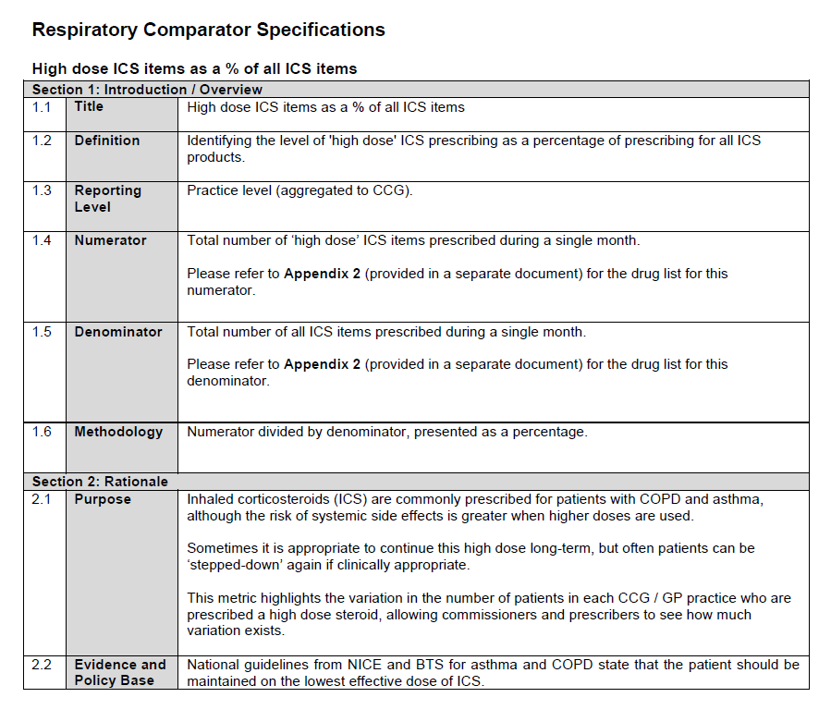

An alternative may be to determine the proportion of patients with COPD who are on triple therapy as follows:

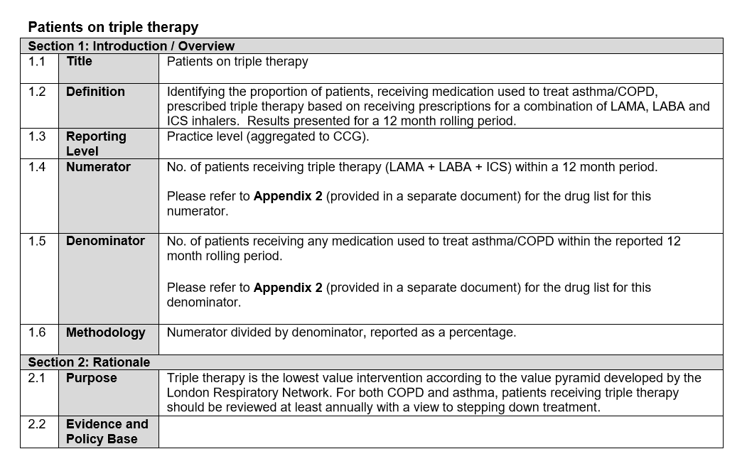

1. Current overuse of high dose ICS in diagnosed asthma
   1. Note: Around 30% of patients with asthma are receiving high dose ICS. Opinion is that an estimated 10% of all asthma patients should be receiving high dose ICS (Comment from Vince, need a reference source for this). Also see above for suggestion to conflate estimates of high dose ICS in patients with either asthma or COPD (or both)
2. Current use of inhalers in misdiagnosed COPD (using figures above)
   1. Note: If alternative diagnosis should have been asthma, then inhaler prescription was likely appropriate. Estimating costs may be challenging here as the outcome of a correct diagnosis is likely to incur costs for alternative treatment/s.
3. Current use of inhalers in misdiagnosed asthma (using figures above)
   1. Note: Determining misdiagnosed asthma may be challenging as the alternative diagnosis (breathing pattern disorder, vocal cord dysfunction) are very difficult to diagnose or treat.
4. Current use of inhalers in people with no diagnosis of asthma or COPD
   1. Note: Data may be available to support the definition of this metric through the CPRD database (Gayle et al 2019). However, costs involved are likely to be small/negligible as it is likely to only involve salbutamol @£1.50 per inhaler

Data for excess SABA prescribing using the EPCT-2 Respiratory dashboard could be derived as follows:

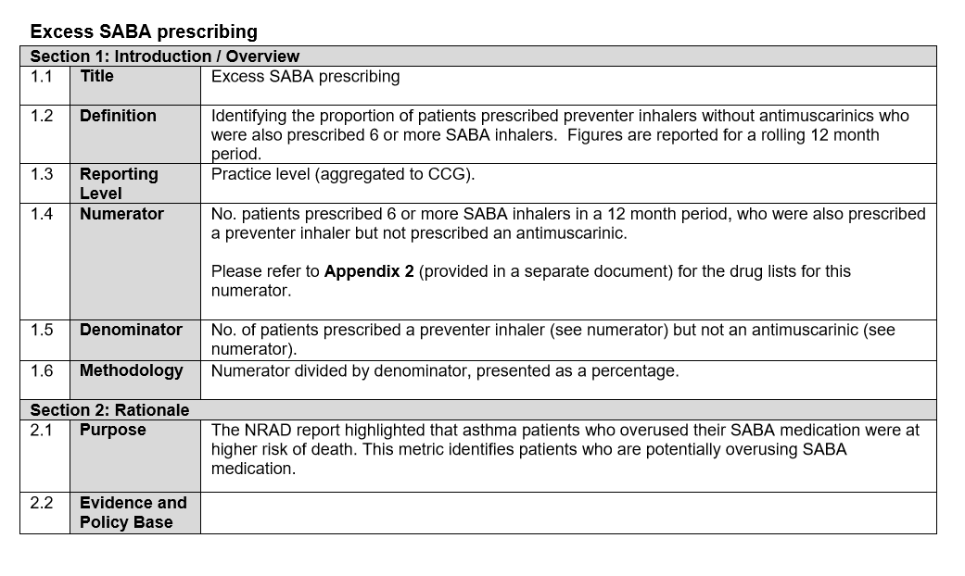

### 2.5 Value-based healthcare

[**This section will**:

* Describe how PCNs and other at scale organisations should look for the opportunities for effectiveness and savings and provide links
* Provide examples of what CCG Baseline assessments have shown from the diagnostic review part and examples of action plans]

## 3.0 Who is this service for?

The service is for people aged 18 and over who live or are registered with a GP within the Network area and where there is shared access to the referred patient’s records:

1. Who continue to experience respiratory symptoms beyond an acute phase or diagnosis (such as URTI or pneumothorax) or where the symptoms are recurrent and when a long-term condition is being considered. The respiratory symptoms would be:
   1. Recurrent wheeze and or chest tightness
   2. Cough (beyond 8 weeks) (NICE CKS: <https://cks.nice.org.uk/cough#!scenario:2>)
   3. Breathlessness that is recurrent or lasting longer than 6 weeks and reaching MRC 2 scale or more
      1. BLF online breathlessness test: <https://breathtest.blf.org.uk>
      2. NICE CKS: <https://cks.nice.org.uk/breathlessness#!scenario:1>
   4. Recurrent ‘chest infection’
2. With suspected asthma where the probability level is low or intermediate (BTS/SIGN 2017; Daines 2017; Stonham and Baxter 2019)
3. With a diagnosis of COPD or asthma where they have not responded as expected to treatment or the accuracy or quality of the diagnosis has come under question for this or other reasons
4. Who have been identified through data analysis (outlined above) to have:
   1. Undiagnosed asthma or COPD
   2. A respiratory diagnosis that does not fit diagnostic criteria (potential misdiagnosis)
   3. Patients admitted to secondary care with a respiratory diagnosis but no previous diagnosis prior to admission.

### 3.1 What will this service provide?

1. Receipt and assessment of referral from any HCP within the Network or Hospital
2. Structured expert feedback using relevant guidance to the referrer prior to the first visit - if required - and after the final visit
3. Perform
   1. Quality assured pre and post bronchodilator spirometry
   2. FeNO testing
   3. Exhaled CO testing
4. Analyse pre-referral tests, service tests and the clinical history to inform the patient and referring clinician of a probable diagnosis and expected next steps

### 3.2 What will the outputs of the service be?

1. **Standard service:** Sufficient information and advice from an expert to the patient and referrer that would allow the start of or continuation of a pathway for treating asthma or COPD within the primary care setting
2. **Higher level service:** Initiation +/- follow up of therapy for a new asthma or COPD diagnosis to be managed within the primary care setting
3. Escalation to a secondary or tertiary specialist for further advice, diagnostics or treatment from either level of service when a diagnosis has not been confirmed or there remains diagnostic doubt

### 3.3 What skillset is required within the service?

The service should be delivered by HCPs with appropriate training, experience and expertise in respiratory care (Lawlor et al 2017). Desirable skills, knowledge and training for HCPs delivering a respiratory diagnostic service may be:

* Completion of or working towards completion of respiratory assessment module/s, for example:
  + Diploma module in asthma
  + Diploma module in COPD
  + NCSCT Training and Assessment Programme for Smoking Cessation or equivalent

**Standard service:**

* An expert HCP in asthma and COPD of sufficient banding and training to formulate and recommend a diagnosis and treatment
* An HCP with the training and qualification to **perform** the relevant tests
* An HCP with the training and qualification to **interpret** the relevant tests

**Higher level service:**

As above plus:

* A prescriber

### 3.4 What health professionals could work in or connect with the service?

* Physicians
  + GP (receive and refer patients; Standard/Advanced respiratory care)
  + A&E physician (receive and refer patients; Standard/Advanced respiratory care)
  + Consultant (accept referrals; Expert respiratory care)
* Nurses (Band 7 or 8) (work within the integrated care system)
  + Practice nurse (receive and refer patients; Advanced respiratory care)
  + Community nurse (receive and refer patients; Standard respiratory care)
  + Community pharmacists (community practice) (receive and refer patients; Standard respiratory care)
* Allied healthcare professionals (work within the integrated diagnostic system)
  + Band 4 healthcare assistants, lung physiology team, nursing assistants)
* Administrator/manager
* IT support

### 3.5 Working with patients and carers to co-design the service?

**[LRG to be asked to contribute to the development of this section]**

## 4.0 The Network Respiratory Diagnostics Service Specification

[**Note:** This section will provide sufficient information for the user network to calculate their own denominator populations in order that they can determine the logistical and clinical requirements for their local service]

### 4.1 The population requiring a service

The population requiring a service are defined as adults aged 18 presenting to their primary care physician with chronic respiratory symptoms (breathlessness, cough). The values calculated here are for a Primary Care Network (PCN) sized population of 50,000 individuals for the denominator population in Year 1 (or more depending on capacity and volume) that need testing. As incorrect diagnoses are resolved the denominator population will be less in subsequent years

|  |  |
| --- | --- |
| **Population requiring a service** |  |

**[An Exel-based calculator tool will be provided based on the metrics collated in the following sections]**

### 4.2 Accommodating people in the service

**[A survey will be conducted via the PCRS Online Platform to inform this section]**

This section describes the number of people per session and number of sessions required per week/month/year for the population needing testing [**Note:** this will need to be adjusted according to final figures calculated in 1.0]

#### Number of people that can be seen in a ‘session’.

Relevant metrics that could be used for calculating an average ‘session’ length in the NICE Resource Impact Appendices for diagnosis of asthma (<https://www.nice.org.uk/guidance/ng80/resources>) and may include:

* Average number of minutes of nurse time to perform objective tests (FeNO, spirometry, reversibility, peak flow, direct bronchial challenge, other?)
* Time allowed to review and repeat unusual tests
* Average number of minutes of [HCP] time to interpret data

|  |  |
| --- | --- |
| **Session length (hours)** | 4 hours |
| **Average appointment duration for *new* patients** | 1 hour |
| **Average appointment duration for *follow-up* appointment** | 0.3 hours |

A typical new patient comprehensive consultation may consist of:

* FeNO: 10–15 minutes
* Spirometry: 20 minutes
* Reversibility: 45 minutes with a 20-minute rest period post bronchodilator
* PEFR: 10 minutes
* Review, interpretation and, if starting treatment, patient education: 30–40 minutes

#### Number of people who will DNA per session

|  |  |
| --- | --- |
| **Number of patients issued an appointment but not attending** | 20% |

#### Time taken to review referrals, write up results and conclusions and provide output back to referrer or into new service

|  |  |
| --- | --- |
| **HCP time per patient** | 0.25 hours |
| **Administrative time (if available) per patient** | 0.25 hours |

## 3.0 Workers within the service

This section will describe the number of workers required per year allowing for leave, sickness selecting from the following skill sets:

[**Note:** this list may change depending on consensus on section 3.4]

* An expert HCP in asthma and COPD of sufficient banding and training to formulate and recommend a diagnosis and treatment
* An HCP with the training and qualification to **perform** the relevant tests (ARTP training, other qualification?)
* An HCP with the training and qualification to **interpret** the relevant tests
* A prescriber
* Management and administration

The number of workers of each skill type will be based on the outputs from Section 1.0 (the number of persons requiring the service) and Section 2.0 (the number of persons that can be seen per ‘session’).

|  |  |
| --- | --- |
| **Number of HCPs (diagnosis and treatment)** |  |
| **Number of HCPs (performing tests)** |  |
| **Number of HCPs (interpreting test results)** |  |
| **Number of administration staff** |  |

## 4.0 Equipment and Consumables

These costs and volume are dependent on what is calculated from Sections 1.0 and 2.0 and 3.0. It is recommended that at least two of each machine (FeNO, exhaled CO and spirometry) be available to account to annual calibration and cleaning.

4.1 FeNO machine:

|  |  |  |
| --- | --- | --- |
| **FeNO machines** | 2 | Estimated cost |
| **Consumables (bacterial filter, disposable mouth tubes)** | Required per year | Estimated cost per year |

* NICE Resource Impact Appendices for diagnosis of asthma (<https://www.nice.org.uk/guidance/ng80/resources>) indicates 5 machines for 100K population

4.2 Exhaled CO monitors:

|  |  |  |
| --- | --- | --- |
| **Exhaled CO monitor** | 2 | Estimated cost |
| **Consumables (disposable mouth tubes, D pieces)** | Required per year | Estimated cost per year |

* 2016 estimates from the London Clinical Senate estimate 20 units for ~6000 tests conducted per year (<http://www.londonsenate.nhs.uk/wp-content/uploads/2015/04/The-expired-carbon-monoxide-CO-test-guidance-for-health-professionals.pdf>

4.3 Spirometery:

|  |  |  |
| --- | --- | --- |
| **Spirometry machines** | 2 | Estimated cost |
| **Consumables (filters, disposable mouth tubes)** | Required per year | Estimated cost per year |

4.4 Bronchial reversibility:

|  |  |  |
| --- | --- | --- |
| **Drugs** | Required per year | Estimated cost per year |
| **Volumetric spacers** | Required per year | Estimated cost per year |

4.5 Peak flow:

|  |  |  |
| --- | --- | --- |
| **Peak flow meter** | Required per year | Estimated cost per year |
| **Consumables (disposable mouth tubes)** | Required per year | Estimated cost per year |

## 5.0 Receipt and assessment of referral

This section will detail the referral and assessment process and the history, examinations and tests that would ideally be available on referral to the service.

[An example of essential components of the initial review and evaluation based on the Southwark CES Breathlessness Guide (<http://www.clinicaleffectivenesssouthwark.co.uk/resources/>)]

5.1: Essential elements in history

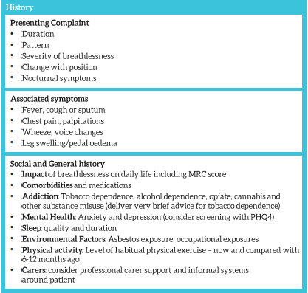

5.2: Essential elements in examination

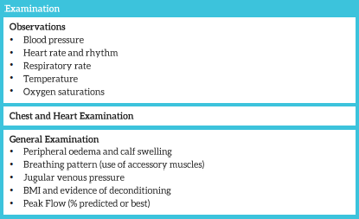

5.3: Essential investigations

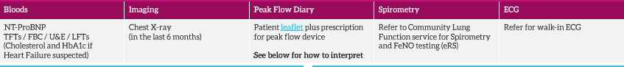

## 6.0 Testing protocol within the Service

This section will detail protocols for objective testing to be conducted following patient referral to the service. Test should be conducted in the following order: FeNO, exhaled CO, spirometry and reversibility.

6.1: Protocol for FeNO testing

***Protocol provided by Joanne King (King Edward VII Hospital, Berkshire); see Appendices for full protocol***

|  |
| --- |
| **Measuring Fractional Exhaled Nitric Oxide (FeNO) using a Bedfont NObreath meter**   1. Obtain informed consent from patient prior to starting test. The patient should be seated. Turn the unit on WITHOUT the flow meter attached. The unit should be in an upright position with the rear exterior port NOT occluded. 2. Attach a new mouthpiece to the flowmeter. 3. Once secured, attach the flowmeter with mouthpiece to the device. 4. Instruct the patient to sit upright, put on a nose clip and hold the machine upright, with the display screen and mouthpiece towards them. Do not cover the rear exterior port. 5. Select either the adult icon or child icon (<12 years of age) depending on your patients age. The child icon requires young participants to blow for 10 seconds, adults for 12 seconds. 6. The machine will beep once. Ask the patient to inhale deeply away from the mouthpiece 7. After three seconds the machine will beep twice - ask the patient to place the mouthpiece in their mouth and exhale moderately, ensuring the silver ball is raised up into the white tabbed region of the flowmeter. 8. Patients should continue to exhale until the progress bar has reached its limit (after 10 or 12 seconds) 9. The machine will beep again, and you will see a measurement on the screen in parts per billion (ppb) 10. Repeat once more, giving two results. These results should be reproducible, i.e. within 10%. The test must be repeated until two sequential results are within 10% of each other, up to a maximum of 8 attempts. |

6.2: Protocol for exhaled CO

[**To be added**]

6.3: Protocol for spirometry

***Protocol provided by Joanne King (King Edward VII Hospital, Berkshire); see Appendices for full protocol***

|  |  |
| --- | --- |
| 1. **Review for contraindications for spirometry** | * Haemoptysis (blood in sputum) * Pneumothorax (puncture in the lung wall) * Unstable heart disease e.g., angina * Unstable hypertension (high blood pressure) * Aneurysm (ballooning) chest, abdomen, cerebral * Recent eye surgery (advice from surgeon) * Acute illness/disorders * Recent thoracic/abdominal surgery (advice from surgeon) |
| 1. **Prepare spirometer** | * Prepare equipment as per manufacturer’s instructions * Accuracy check to be performed prior to clinic and then every 4 hours. A 3L or 1L Syringe is to be used, calibration should produce a measured value within +/- 3% * Spirometer should be kept at room temperature if possible * Cleaning and maintenance - as per manufacturer’s instructions, for destruction of pathogens by chemical means |
| 1. **Infection prevention** | * One Way filters - disposable (single patient use) * Calibration - all components assembled - check for leaks (keep at same temperature as room) lf calibration pre-set, use physiological check (member of staff with known normal values) Record data * lf patient known or suspected MRSA, TB, HIV, Pseudomonas infection, or Hep B, q=use a SafeTway mouthpiece or a BVF (single patient use) and preferably perform spirometry at the end of clinic |
| 1. **Perform procedure** | **Explain and demonstrate each procedure to the patient, ensure patient is sitting comfortably:**   1. Relaxed VC (Vital Capacity) x 3 blows    * Nose clip should be worn during this manoeuvre    * Take a deep breath in. Put mouthpiece into mouth behind front teeth, and then exhale as far and as long as possible in their own time.    * Verbally encourage ++    * Need two blows within 5% or 100mls of each other    * Remove nose clip 2. Forced VC x 3 blows (nose clip is not essential)    * As above for inspiration    * Blow out as hard and as fast as possible for as long as possible - maximum effort needed    * Verbally encourage ++    * Observe the flow/volume curve as each FVC manoeuvre is being performed to identify slow starts, early stops or variability in flow within manoeuvre    * Need best of two blows within 5% or 100mIs to 150mls of each other    * Maximum of 8 blows at one sitting   If patient is unable to achieve these standards, document why this is and consider rebooking or referring to clinic medical team.  **BRONCHODILATOR REVERSIBILITY (using a SHORT ACTING BRONCHODILATOR)**   * Baseline FEV1, FVC, VC recorded as above * Ensure technically acceptable baselines before the administration of a Short Acting Beta Agonist (SABA) - 2.5mg Salbutamol administered via a nebuliser or 400mcg Salbutamol inhaler (4 Puffs) via disposable Spacer device * The SABA administration should be discontinued if the patient complains of symptoms such as increased shortness of breath/wheeze, palpitations, flushing * The monitoring of the patients pulse rate and BP is recommended for susceptible patients ie Hyperthyroidism, cardiovascular disease, arrhythmias, hypertension * After the short acting bronchodilator has been administrated wait for 20minutes then repeat spirometry recording - FEV1, FVC, VC * In Asthma - an increase in FEV1 of 200mls/12% may indicate Asthma * In COPD – A limited degree of reversibility or none would indicate COPD. Post bronchodilator FEV1 % is recorded for classification of disease (GOLD classification)   Consider oral steroid trial (30mgs oral prednisolone for 2 / 52) and repeat forced blows  **Transfer results onto spirometry template in the notes and flow/volume and time/volume graphs to be secured or scanned into the patients notes.** |

## 7.0 Best practice examples of referrer and patient feedback and information

[Reporting templates will be included here]

## 8.0 Recommended coding

[NACAP coding for asthma, COPD, tobacco dependency]

|  |  |  |  |
| --- | --- | --- | --- |
| **Read Code** | **v2 Term30** | **SNOMED conceptid** | **SNOMED descriptionid** |
| H3...00 | Chronic obstructive pulm.dis. | 13645005 | 475431013 |
| H33 | Asthma | 195967001 | 301485011 |
| H3122 | Acute exacerbation of chronic obstructive airways disease | 195951007 | 301453013 |
| H333 | Acute exacerbation of asthma | 304527002 | 446841017 |
| 137R | Current smoker | 77176002 | 503483019 |
| 137S | Ex smoker | 8517006 | 15047015 |
| 66Yf | Numb COPD exacer in past year | 723245007 | 3335171010 |
| 663y. | Num asthm exacs in past year | 366874008 | 490425015 |
| 8H7i. | Referral: smok cessatn advisor | 395700008 | 1489355012 |
| 745H4 | Smoking cessation drug therapy | 713700008 | 3297364011 |

## 9.0 Performance and Quality Metrics

[Suggestions include: NACAP queries that cover asthma and COPD diagnosis and observed:expected rates (via PHE dashboards)]

## 10.0 Integrating the network service to secondary and tertiary care

[Interviews will be conducted with people already involved in diagnostic services to describe how they organise their teams to assess difficult diagnoses/escalations]

**References**

Baxter N. Breathlessness in the primary care setting. Curr Opin Support Pall Care 2017;11:152-158.

BTS/SIGN. SIGN 153. British guideline on the management of asthma. Published September 2016. Available at: <https://www.brit-thoracic.org.uk/document-library/clinical-information/asthma/btssign-asthma-guideline-2016/>. Accessed May 2019.

Daines L, et al. Clinical prediction models to support the diagnosis of asthma in primary care: a systematic review protocol. npj Prim Care Respir Med 2018;28:15.

Daines L. Asthma guidelines in practice – A PCRS-UK consensus. PCRU 2017 [citation to be updated]

Figarska SM, Boezen HM, Vonk JM. Dyspnoea severity, changes in dyspnoea status and mortality in the general population: The Vlagtwedde/Vlaardingen study. Eur J Epidemiol. 2012;27:867–876

Gayle A, et al. Real-life prescribing of asthmatic treatments in UK general practice over time using 2014 BTS/SIGN steps. npj Prim Care Respir Med 2019;29:25

Gray M. Value based healthcare. BMJ 2017;356:j437.

Hopkinson S, et al. Breathing SPACE – a practical approach to the breathless patient. Npj Primary Care Respir Med 2017;27:5.

Jayatunga W, et al. Code sets for respiratory symptoms in electronic health records research: a systematic review protocol. BMJ Open 2019;9:e025965.

Jones RCM, et al. Opportunities to diagnose chronic obstructive pulmonary disease in routine care in the UK: a retrospective study of a clinical cohort. Lancet Respir Med 2014;2:267–276.

Lawlor R. Fit to care: key knowledge skills and training for clinicians providing respiratory care. PCRS-UK/FTC/JUN2017/V1. Available at: [https://www.pcrs-uk.org/sites/pcrs-uk.org/files/FitToCare_FINAL.pdf. Accessed May 2019](https://www.pcrs-uk.org/sites/pcrs-uk.org/files/FitToCare_FINAL.pdf.%20Accessed%20May%202019).

Pearson M, et al. Diagnosis of airway obstruction in primary care in the UK: the CADRE (COPD and Asthma Diagnostic/management Reassessment) programme 1997-2001. Int J Chron Obstruct Pulmon Dis 2006;1:435-43.

Roberts NJ, et al. The diagnosis of COPD in primary care; gender differences and the role of spirometry. Respir Med 2016;111:60-63.

Shabab L, et al. Prevalence, diagnosis and relation to tobacco dependence of chronic obstructive pulmonary disease in a nationally representative population sample. Thorax 2006;61:1043-1047. [Jennifer Quint is currently running and study to identify code sets for the identification of patients with respiratory symptoms in electronic health records]

Stonham C, Baxter N. FeNO testing for asthma diagnosis – A PCRS consensus. *In preparation.*

Ward DG, et al. How accurate is diagnosis of asthma in a general practice dataset? A review of patients’ notes and questionnaire-reported symptoms. Br J Gen Pract 2004;54:753-758.

# Appendices

## Appendix 1: FeNO protocol (using a Bedfont NObreath meter)

**Provided by Joanne King (King Edward VII Hospital, Berkshire)**

**TRUST SPIROMETRY PROTOCOL**

**Measuring Fractional Exhaled Nitric Oxide (FeNO)**

**using a Bedfont NObreath meter**

* Nitric oxide (NO), produced in the lungs and present in exhaled breath, has been shown to act as an inflammatory mediator in the lungs and airways
* Eosinophilic asthma is a distinct phenotype associated with a rise in NO in exhaled breath
* Eosinophilic asthma may respond to treatment with corticosteroids, while neutrophilic asthma generally does not
* FeNO can be used to measure steroid responsive, eosinophil driven airway inflammation
* Higher levels of airways inflammation are associated with poor asthma control

-NICE, 2014

**Measured in parts per billion (ppb):**

* Low range: <25ppb in adults, <20 in children *
* Intermediate range: 25-50ppb in adults, 20-35 ppb
* High range: >50 in adults, >35 in children **

* In atopic individuals, higher values may be considered normal

** In patients with a value >50ppb(adult) / 35ppb (child), who are on high dose ICS, adherence may be questioned (McNicholl et al 2012)

FeNO may be suppressed by smoking, oral or inhaled corticosteroid, exercise, alcohol consumption, bronchoconstriction, ciliary dyskinesia, pulmonary hypertension, cystic fibrosis

FeNO may be higher in airway infection, allergic rhinitis, nitrate-rich diet, bronchodilator (Taylor et al 2006)

**Procedure**

**FeNO testing should be undertaken BEFORE spirometry**

1. Obtain informed consent from patient prior to starting test. The patient should be sat down. Turn the unit on WITHOUT the flow meter attached. The unit should be in an upright position with the rear exterior port NOT occluded.
2. Attach a new mouthpiece to the flowmeter.
3. Once secured, attach the flowmeter with mouthpiece to the device.
4. Instruct the participant to sit up, put on a nose clip and hold the machine upright, with the display screen and mouthpiece towards them. Do not cover the rear exterior port.
5. Select either the adult icon or child icon (less than 12 years of age) depending on your participant’s age. The child icon requires young participants to blow for 10 seconds, adults for 12 seconds.
6. The machine will beep once, ask participant to inhale deeply away from the mouthpiece
7. After three seconds the machine will beep twice - ask the participant to place the mouthpiece in their mouth and exhale moderately, ensuring the silver ball is raised up into the white tabbed region of the flowmeter.
8. Participants should continue to exhale until the progress bar has reached its limit (after 10 or 12 seconds).
9. The machine will beep again and you will see a measurement on the screen in parts per billion (ppb).
10. Repeat once more, giving two results. These results should be reproducible, i.e. within 10%. The test must be repeated until two sequential results are within 10% of each other, up to a maximum of 8 attempts.

**References:**

* NICE (2014) *Measuring FeNO concentration in asthma.* <http://www.nice.org.uk/guidance/dg12/resources/measuring-fractional-exhaled-nitric-oxide-concentration-in-asthma-niox-mino-niox-vero-and-nobreath-1053626430661>
* McNicholl, D.M., Stevenson, M., McGarvey, L.P., Heaney, L.G. (2012) ‘The utility of fractional exhaled nitric oxide suppression in the identification of nonadherence in difficult asthma’. *American Journal of Respiratory Critical Care Medicine.* 186(11), pp1102-1108.
* Taylor DR, Pijnenburg MW, Smith AD, De Jongste JC. Exhaled nitric oxide measurements: clinical application and

interpretation. *Thorax*. 2006;61(9):817-27.

## Appendix 2: Spirometry protocol

**Provided by Joanne King (King Edward VII Hospital, Berkshire)**

**TRUST SPIROMETRY PROTOCOL**

**PRE-TEST REQUIREMENTS**

**Health and Safety of patient**

Documentation of medications used prior to test.

Ensure patient is sitting down during tests.

**Explanation leaflet for patient with instructions, ideally when booking for test**

**Patients condition must be stable**

ldeally patient should avoid:

* Smoking for 24 hours (or shorter if unable to comply)
* Alcohol for 4 hours
* Exercise for 30 minutes
* Eating substantial meal for 2 hours

**For diagnostic spirometry**, patient should avoid:

* Taking short acting bronchodilators for 4 hours (Salbutamol Terbutaline)
* Taking long acting bronchodilators for 24 hour( Tiotroprium, Salmeterol, Formoterol)

**For follow up spirometry**, all inhaled therapy should be taken as usual, prior to test.

Bring all inhalers to appointment

All patients should wear comfortable, non restrictive clothing  
Wear dentures if possible. Females empty bladder  
Patient should arrive early for appointment, as need to be seated 10 minutes to settle any exertional dyspnoea  
Check information before test and record any deviation  
Accurate height and weight should be recorded.

**CONTRAINDICATIONS FOR SPIROMETRY**

* Haemoptysis (blood in sputum)
* Pneumothorax (puncture in the lung wall)
* Unstable heart disease e.g., angina
* Unstable hypertension (high blood pressure)
* Aneurysm (ballooning) chest, abdomen, cerebral
* Recent eye surgery (advice from surgeon)
* Acute illness/disorders
* Recent thoracic/abdominal surgery (advice from surgeon)

**PREPARATION OF SPIROMETER**

* Prepare equipment as per manufacturer‘s instructions
* Accuracy check to be performed prior to clinic and then every 4 hours. A 3L or 1L Syringe is to be used, calibration should produce a measured value within +/- 3%
* Spirometer should be kept at room temperature if possible
* Cleaning and maintenance - as per manufacturer‘s instructions, for destruction of pathogens by chemical means.

**FREQUENCY OF CLEANING** - best practice would include daily, post session and weekly documented cleaning procedures.

Must be disinfected every 100 patients or monthly. (Please see Cleaning Protocol)

**FREQUENT HAND WASHING TO PREVENT INFECTION BETWEEN INDIVIDUALS**

One Way filters - disposable (single patient use)

Calibration - all components assembled - check for leaks (keep at same temperature as room) lf calibration pre-set, use physiological check (member of staff with known normal values) Record data

lf patient known or suspected:

* MRSA
* TB
* HIV
* Pseudomonas
* Hep B

Use a SafeTway mouthpiece or a BVF (single patient use) and preferably perform spirometry at the end of clinic.

**Procedure**

**Equipment and patient prepared as above, explain and demonstrate each procedure to the patient, ensure patient is sitting comfortably:**

1. Relaxed VC (Vital Capacity) x 3 blows
   * Nose clip should be worn during this manoeuvre.
   * Take a deep breath in. Put mouthpiece into mouth behind front teeth, and then exhale as far and as long as possible in their own time.
   * Verbally encourage++
   * Need two blows within 5% or 100mls of each other
   * Remove nose clip
2. Forced VC x 3 blows (nose clip is not essential)
   * As above for inspiration
   * Blow out as hard and as fast as possible for as long as possible - maximum effort needed
   * Verbally encourage ++
   * Observe the flow/volume curve as each FVC manoeuvre is being performed to identify Slow starts, Early stops, Variability in flow within manoeuvre
   * Need best of two blows within 5% or 100mIs to 150mls of each other
   * Maximum of 8 blows at one sitting

If patient is unable to achieve these standards, document why this is and consider rebooking or referring to clinic medical team.

**BRONCHODILATOR REVERSIBILITY (SHORT ACTING BRONCHODILATOR)**

* Baseline FEV1, FVC, VC recorded as above
* Ensure technically acceptable baselines before -

**BRONCHODILATOR REVERSIBILITY (using a SHORT ACTING BRONCHODILATOR)**

* Baseline FEV1, FVC, VC recorded as above
* Ensure technically acceptable baselines before the administration of a Short Acting Beta Agonist (SABA) - 2.5mg Salbutamol administered via a nebuliser or 400mcg Salbutamol inhaler (4 Puffs) via disposable Spacer device
* The SABA administration should be discontinued if the patient complains of symptoms such as increased shortness of breath/wheeze, palpitations, flushing
* The monitoring of the patients pulse rate and BP is recommended for susceptible patients ie Hyperthyroidism, cardio vascular disease, arrhythmias, hypertension
* After the short acting bronchodilator has been administrated wait for 20minutes then repeat spirometry recording - FEV1, FVC, VC
* In Asthma - an increase in FEV1 of 200mls/12% may indicate Asthma
* In COPD – A limited degree of reversibility or none would indicate COPD. Post bronchodilator FEV1 % is recorded for classification of disease(Gold classification)

Consider Oral Steroid trial (30mgs oral Prednisolone for 2 / 52) & repeat forced blows

**Transfer results onto spirometry template in the notes and flow/volume and time/volume graphs to be secured or scanned into the patients notes.**

**ACCOUNTABILITY**

Factors that impact on a Health Care Professional / Health Care Assistant when conducting a spirometry assessment;

1. Code of professional conduct.
2. Accountability for actions and omissions.
3. Duty of care to your patients and clients who are entitled to receive safe and competent care.
4. Duty to maintain and increase your knowledge, skills and abilities required for lawful, safe and effective practice
   1. within direct/ indirect supervision - HCA
   2. without supervision - qualified clinician
5. Acknowledge limitations of professional competence and only accept responsibilities at which you are competent.
6. Adherence to the spirometry protocol

Reference: PPC (2013) Guide to performing Quality assured Spirometry

Trust Protocol for calibration/verification of Spirometers

All spirometry standards (e.g. ATS/ERS/BTS/ANZRS) recommend checking

the accuracy of lung function measuring devices at least daily with a 3-L

syringe to validate that the instrument is measuring accurately. The

Vitalograph ALPHA should never be outside accuracy limits unless damaged

or in a fault condition. In normal use, calibration traceability certification is

recommended as a part of the routine annual service. ATS (1994)

recommendations require that the difference between the volume measured

by the spirometer and the volume pumped into the spirometer from a syringe

is within 3%.

The purpose of calibrations or verification of the spirometer is to ensure that the device produces accurate results; inaccurate results could lead to inappropriate treatment for patients.

The health care professional performing the accuracy check has been trained and completed local trust competency on preparing the device and performing spirometry.

**Pre check**

Check for visible damage to device and cables – withdraw from service and report to the medical device department for repair, follow trust guidelines in reporting faults.

Check for any contamination to the flow head. If there is visible contamination then withdraw the device from service and follow the cleaning protocol.

Check that all components are assembled correctly.

Check for any leaks by using the calibration syringe.

Check room temperature, document in verification log.

**Accuracy Check**

A 1litre syringe is provided to use, the calibration should produce a measured value of 3Litres within a 3% margin.

An accuracy check should be performed:

Before each clinic session or every 4 hours if used all day.

After every 10 patients

If there is a change in ambient temperature

If the flow head is dropped

After cleaning or dismantling of the spirometer for any reason

Follow these steps to check the accuracy of the unit.

1. Pump air through the flow head to ensure it’s at ambient temperature, may require several pumps if spirometer has been moved from a cold environment.
2. Select Accuracy Check from the Main Menuusing the keypad.
3. Press the ‘Enter’ key to bring you into the Accuracy Check screen and follow the on-screen instructions.

***Note:*** *Press the ‘Del’ key to exit the Accuracy Check screen and return to the Main**Menu.**The accuracy check will not be logged to the Vitalograph ALPHA memory in this case.*

1. If an Accuracy Check report is required select the Report option.

***Note:*** *If the device is outside calibration you will be given the option to update the calibration. If you select this option you will be brought through the accuracy check routine again.*

1. Complete calibration log book and sign.

In the event the accuracy check is outside the +/-3%, then refer to the manufacturer’s manual on fault finding. Repeat the accuracy check. If the accuracy check continues to fail remove from service and report, follow trust guidelines on reporting equipment faults.

**When to Check Accuracy**

* + Monthly or after every 10 patients
  + After annual maintenance checks
  + After cleaning or disassembling spirometer for any reason
  + After adjusting calibration
  + If the flow head has been dropped

**Error in calibration**

Accuracy check variations > +/-3%/False readings suspected

In the event the accuracy check is outside the +/-3%, then refer to the manufacturer’s manual on fault finding. Repeat the accuracy check. If the accuracy check continues to fail remove from service and report, follow trust guidelines on reporting equipment faults.

**Maintenance .**

To maintain quality assurance and accuracy of calibration, the spirometry must have a yearly service and certified calibration by the manufacture of the spirometer.

Reference

American Thorax Society (ATS) 1994 Guideline for the measurement of respiratory function *Respiratory Medicine* 1994 (88), 165-194

**Cleaning Procedure (Chest Clinic)**

For lung function testing the main risks are:

* The cross infection of pathogenic organisms between patients
* The cross infection of pathogenic organisms to an immuno compromised patient, such as a lung transplant recipient.

The source of the infection must also be considered, the source could be airborne (coughing, sneezing) or body fluids (sputum, blood).

A new mouthpiece is to be used for each patient with a delay of 5 minutes in between patients to allow the particles to settle. In the event of visible contamination, the flowhead must be disinfected.

The cleaning protocol is based on the manufactures instructions, assuming 500 blows or 100 patients (modified from Vitalograph Alpha 6000 User manual)

|  |  |  |  |
| --- | --- | --- | --- |
| **PART** | **CLEAN/DISINFECT** | **FREQUENCY** | **CLEANING PRODUCT** |
| Case exterior | Clean | After each patient | Sani-Cloth |
| Flow head tube | Clean | Weekly | Sani-Cloth |
| Screen | Clean | Daily | Wipe with cotton pad |
| Fleisch Element  Flowhead body  Flowhead cone  Flowhead end cap  Flow conditioning mesh | Clean  Clean & Disinfect  Clean & Disinfect  Clean & Disinfect  Dispose & Replace | Weekly  Weekly  Weekly  Weekly  Weekly | Immerse in Chlor clean tablets (to be made as protocol) for 15 minutes. |

|  |  |
| --- | --- |
|  | 1. Flowhead Complete – 61030 2. 'O' rings - 2120013 3. Flowhead End Cap -62006SPR 4. Flow Conditioning Meshes - 42084 5. Flowhead Cone - 62019SPR 6. Fleisch Element - 62055SPR 7. Flowhead Body – 61020 8. Lubrication: Silicone Grease – 30961SPR |

**Figure 2: Flowhead Assembly**(taken from Vitalograph Alpha 6000 User Manual**)**

## Appendix 2: Evaluation of the NHS Breathlessness Pilots: Report of the evaluation findings.

