PCRS Workforce audit
Guide Booklet 2020
This project has been supported by an arm’s length grant provided by Chiesi Limited

Once the excel spreadsheet is opened you should see the workbook – please not when you open it will be blank.
You will see at the bottom there are a number of tabs. The data entry tab (GREEN) is the one in which you will enter all your questionnaire results.
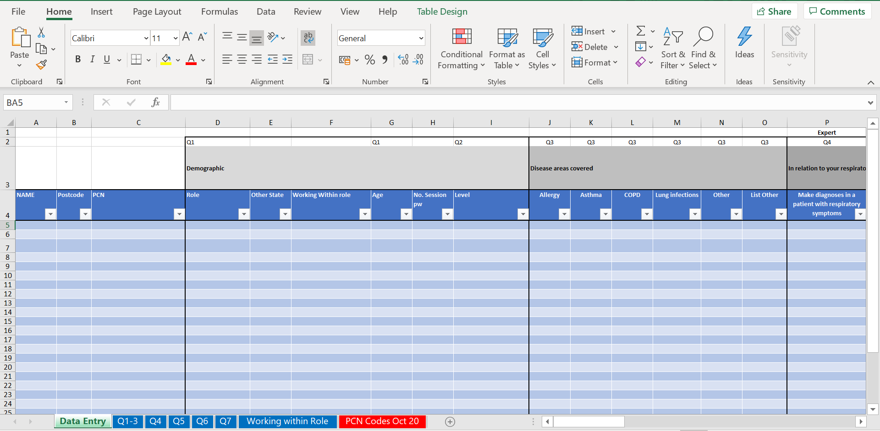

The remaining tabs (BLUE) are the outputs from your data, helping to highlight the results of the questions asked.
The PCN Codes Oct 20 (RED) tab is data taken from the NHS Business Authority which helps reference practice postcodes to the PCN they were recorded as being part of in October 2020.

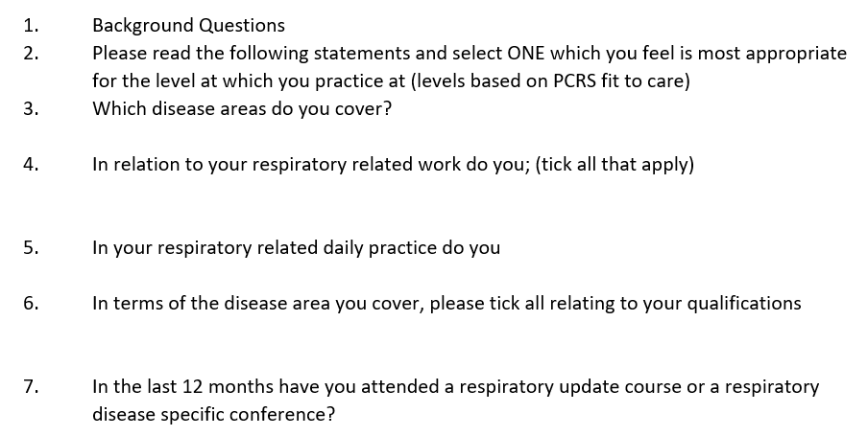
The questions asked were as follows;

Collect all your questionnaire responses and then add result to the GREEN tab on the spreadsheet.
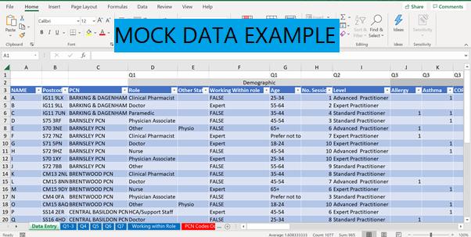

For the Post code column please note a space is required to pre-populate the PCN the practice is associated with (based on NHS Business Services data (accessed October 2020)
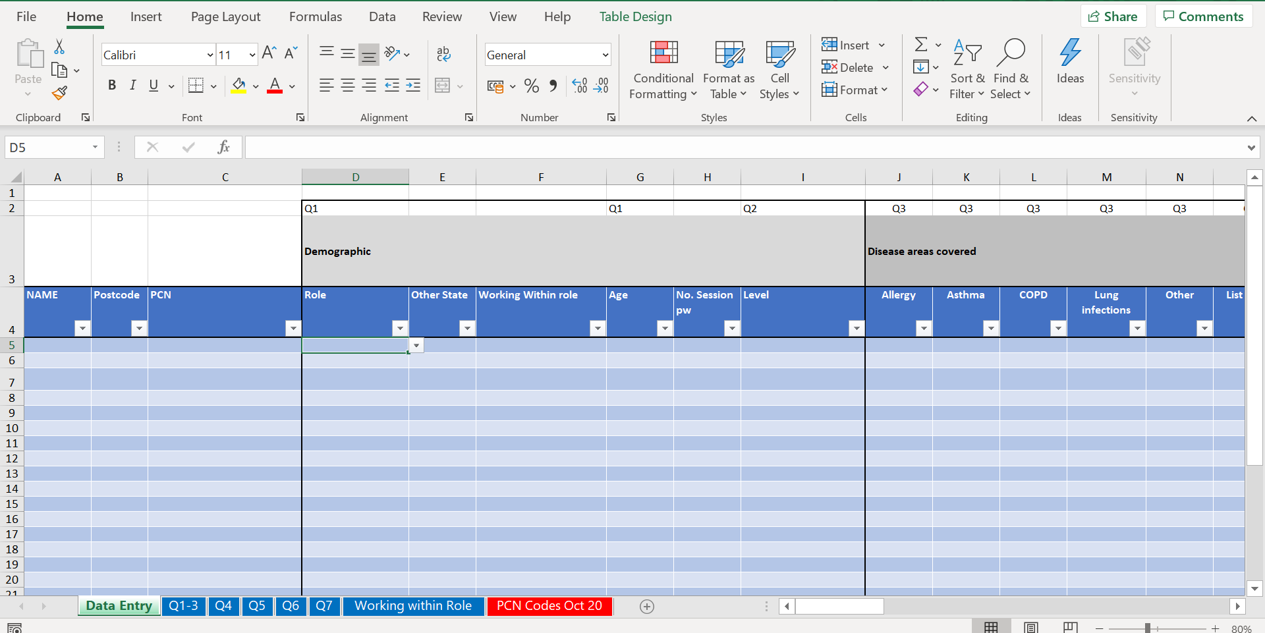
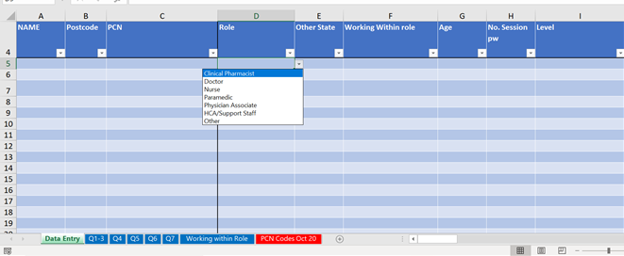

When adding the information, you will be able to select the response answer on several of the columns. Click on the cell and an arrow will appear, you can then select the response as shown above.
When you come to enter response for questions 4, 5 and 6 as there are many response that those completing the questionnaire may has selected, you will need to put a 1 if the questionnaire answer is ticked. This allows a calculation of the numbers to be done for the output tabs (GREEN).

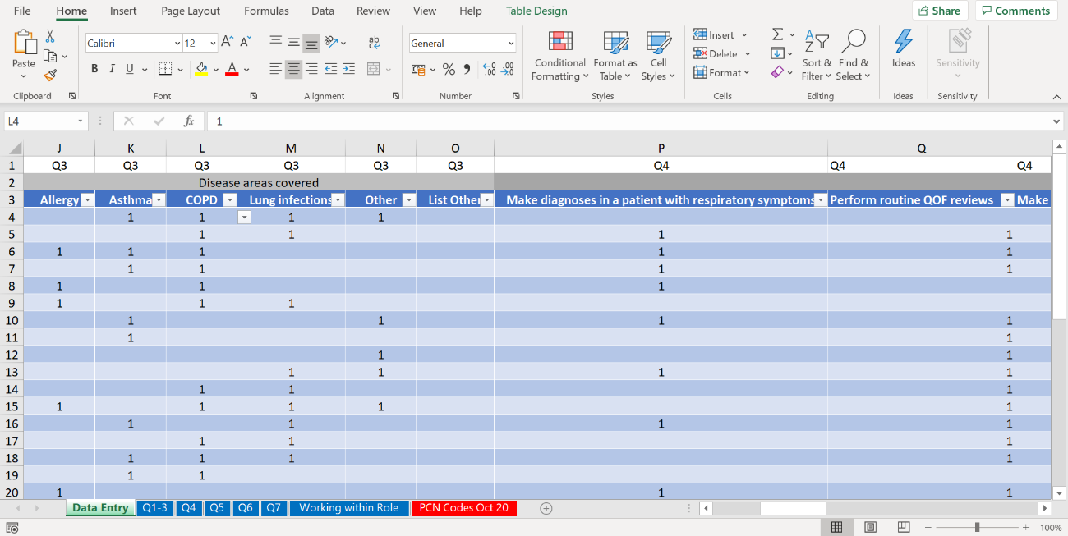
Here is an example of the responses completed for several questions 3 and 4;

One the data tab there is also the ability to “filter” results on this data tab (top tip – do this when all data is entered).
The filtering function can be done on almost any element on the table. For example, if the audit spans more than 1 PCN, you can filter results to just see the raw data from a particular PCN. Once data is entered click the arrows the reveal options that can be filtered (example below).

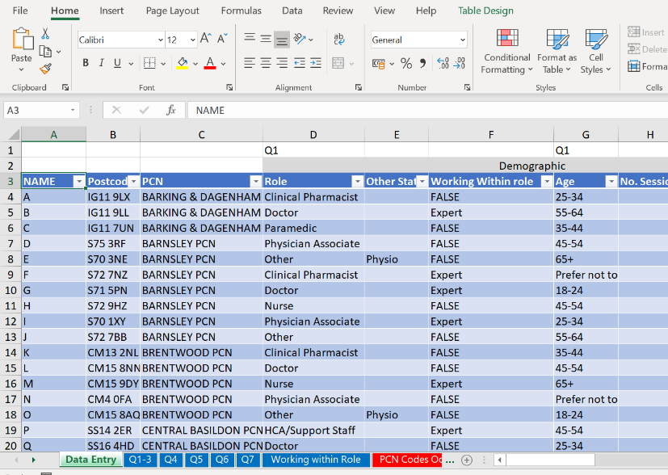

Here is another example of filtering on the PCN column;
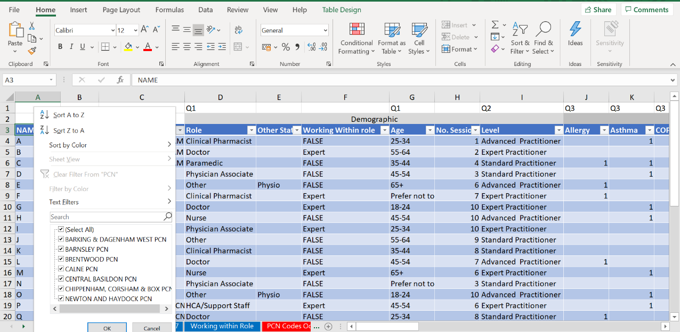

If you have filtered responses, you will see this funnel symbol;
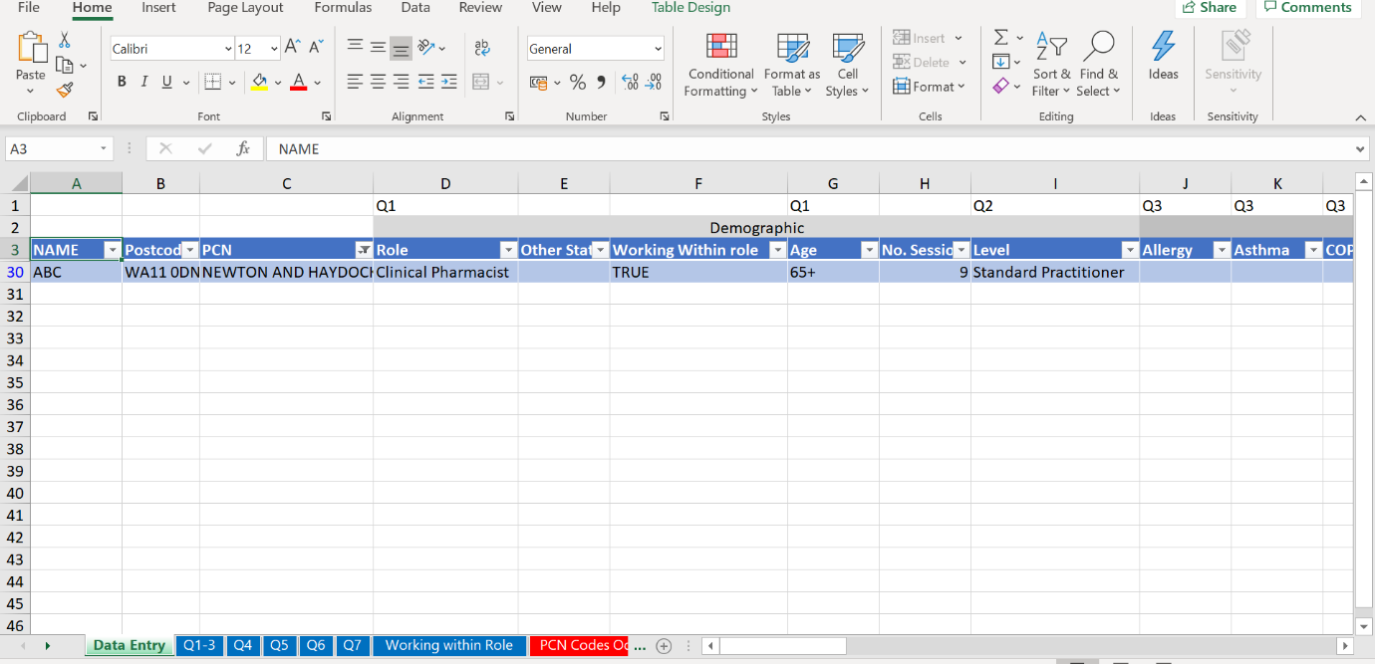

Output Tabs (GREEN)
Once data in entered in the BLUE tab you can then review the outputs.
Q1-3 has a range of “pivot tables”
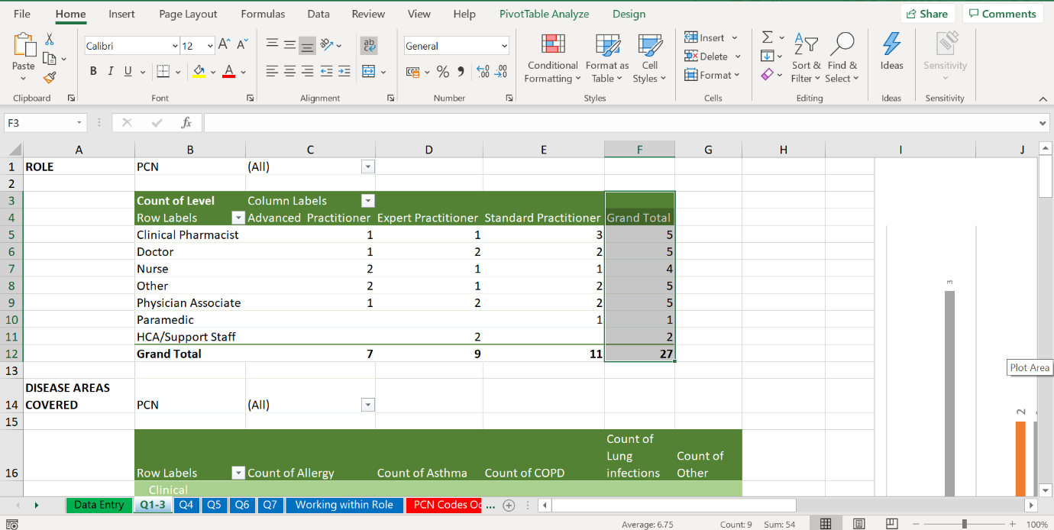

These will need to be “refreshed” if additional data is put into the raw data (BLUE) tab. To refresh just right click on the table and select “refresh”
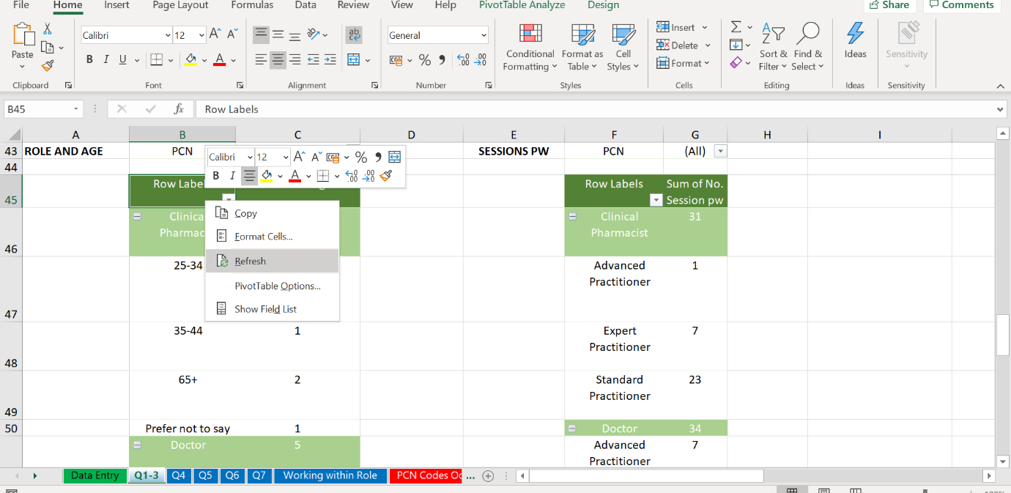
All Charts can also be edited (colours/font/size etc) by right clicking on your mouse.
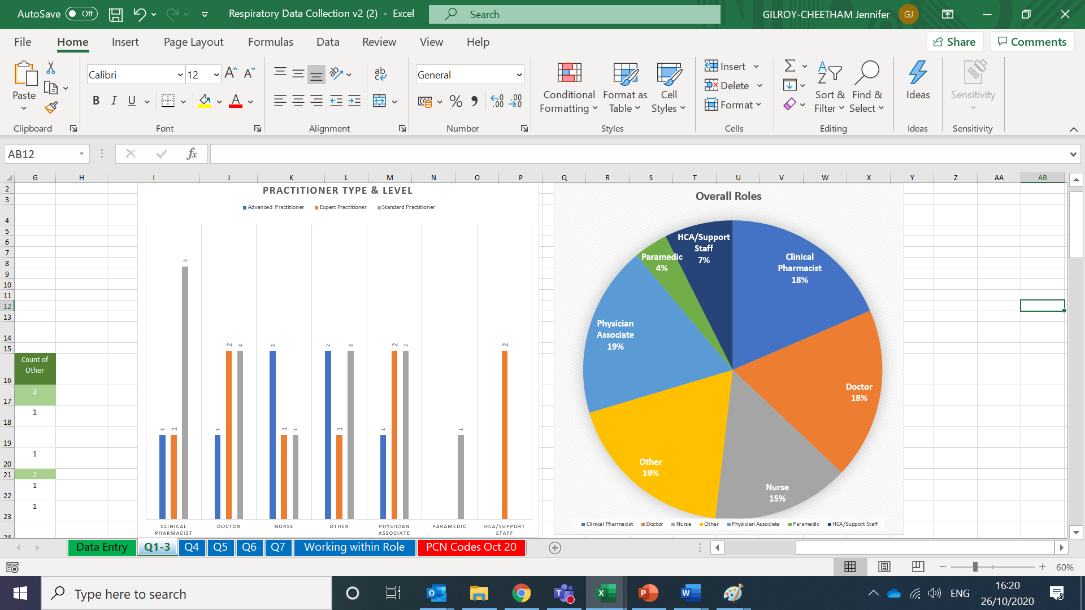

Working with role tab - allows you to see self-rated practitioner levels against roles undertaken.
This allows you to see who is working above their self-rated practitioner level. This is particularly important as it allows those conducting the audit to deep dive further and indeed consider if additional training is required to help support staff to undertake activities and to celebrate the great workforce within an area and all the work that is being undertaken.
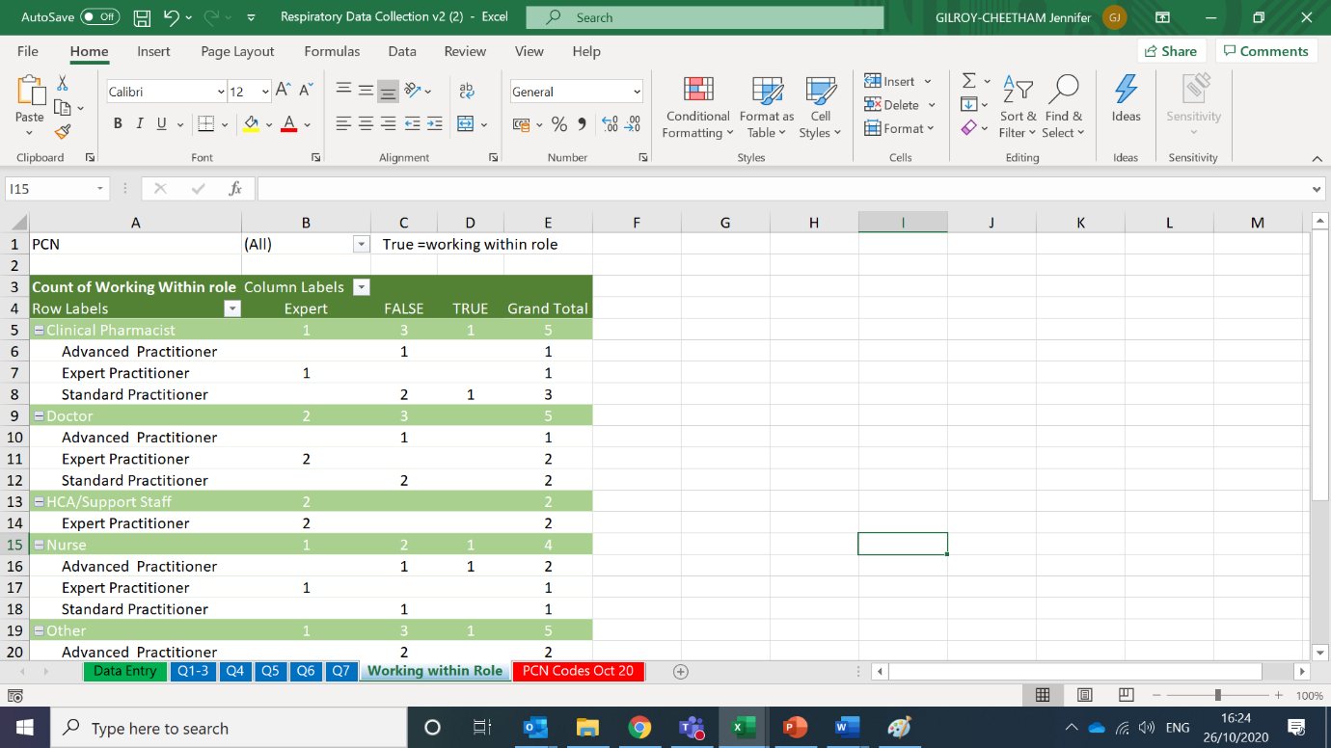

From the example above you can see that 5 people identified as Clinical Pharmacists.
The person who self-rate as an Advanced practitioner is undertaking activities that are above this level and therefore you will see a “1” in the FALSE column. In order to know what they are doing that is perhaps more of an expert role you will need to go to the raw data tab and review.
The self-rated Expert Practitioner row shows in the TRUE column – indicating they are completing activities within there level according to fit-to-care.
Within the self-rate standard practitioner row – there are three people identifying at this level. Two responses are within the true column indicating they are undertaking activities within their role. Another is false indicating they have selected an activity which is deemed as being either an advanced or expert level role. To understand what they selected you will need to review the raw data input (BLUE) tab.

